The Open-Source Audit

A Capstone Project for OSS NGMC Course

Chosen Software: MySQL

Student Name | Registration Number
Ambrish Raj | 24BHI10019
Slot | Date of Submission
B22 | 30.03.2026

Part A — Origin and Philosophy

A1. The Problem MySQL Was Created to Solve

Early Challenges in Database Management

Organizations faced major difficulties when they needed to handle large amounts of data during the first part of the 1990s. The internet expansion needed website owners and application developers to develop an effective system which would handle data storage and access and data organization. The database systems which existed during that period included Oracle and IBM DB2 but they came with high operational expenses and complex system management requirements. The proprietary solutions operated outside the financial range which small businesses together with individual developers and students could handle. The market lacked an economical database system which would provide users with an easy-to-use solution.

Shortcomings of Existing Database Systems

One of the lighter alternatives available at that time was mSQL (miniSQL). The mSQL database system did not offer sufficient database management capabilities. The system restricted users from accessing full SQL capabilities while it slowed down when working with extensive data sets and it failed to deliver essential tools which programmers needed to develop standard software applications. Users encountered problems because the free options did not meet their needs and the premium options exceeded their budget.

The Birth of MySQL

To address these problems, Michael "Monty" Widenius and David Axmark began working on a new database system in 1995. The founders established MySQL AB as a business which operated from Sweden. The team aimed to develop a database system which would provide quick performance and dependable operation and user-friendly interface and maintain its free open source nature. The name MySQL originated from Monty's daughter's name which he combined with the SQL abbreviation for Structured Query Language. MySQL was created to deliver better speed performance than mSQL while supporting all SQL features.

Goal and Purpose

MySQL started as a free open-source relational database management system which developers could use for their projects. The system provided database management tools which students could learn about databases and startups could use to develop their initial web application. Developers obtained access to the source code which they could use to study and modify and enhance the program according to their requirements.

Growth and Impact

MySQL quickly became one of the most popular database systems in the world. The platform offered web developers three essential features because it combined fast performance with dependable operation and

free access. MySQL became the database solution which Facebook YouTube Twitter and Wikipedia selected
for their platform needs. Sun Microsystems acquired MySQL AB in 2008 before Oracle Corporation
purchased Sun Microsystems in 2010 which established Oracle as the new owner of MySQL. The acquisition generated doubts among open-source developers which led Monty Widenius to establish MariaDB as an independent MySQL development project.

A2. The License — What It Actually Says

Understanding MySQL's License

MySQL uses a dual-licensing model. The Community Edition of MySQL is released under the GNU General Public License version 2 (GPL v2). This is a copyleft open-source license that ensures the source code remains free and accessible. Oracle provides a Commercial License to businesses which want to avoid following the GPL requirements in addition to the GPL. MySQL operates with two different licensing systems which enable users to benefit from its open-source features and commercial functionalities. The Four Freedoms of Open Source
The open-source software philosophy is based on four fundamental freedoms. The four essential freedoms include: The right to operate the software without any limitations. Users have the right to analyze software operations and perform alterations to the code. Users have the right to distribute duplicate copies of the software. Users have the right to distribute any changes they have made to the software. MySQL under the GPL license satisfies all four of these freedoms, ensuring that users have complete control over the software.

Can Companies Modify and Sell It?

Under the GPL license, companies can modify MySQL, but they must also release their modifications as open source. All projects which base their work on GPL-licensed software must use the same GPL license for their resulting software. However, if a company wants to keep its modifications private, it can purchase a Commercial License from Oracle. MySQL operates through a dual licensing system which establishes it as a one-of-a-kind software product because Apache License software does not enforce such limitations. The GPL License requires developers to share all their modified software version source code with the entire community.

GPL vs MIT vs Apache License

The GPL license is a strict copyleft license that requires all derived works to be open source. The MIT License grants users complete freedom to use the software without any significant restrictions. The Apache License operates like the MIT License but adds extra protection for patents and defines how contributors should participate. The GPL license establishes the highest level of protection for open-source principles because it mandates all software including its derived versions to stay free. I would select the GPL license for my project because it guarantees that my work will always stay open source.

Free vs Freedom

There is a fundamental difference between "Free as in Free Beer" and "Free as in Freedom." The phrase "Free as in Free Beer" describes items which people can access without needing to pay anything but "Free as in Freedom" describes their ability to use software openly. Users can access software without payment through the Free as in Free Beer concept but Free as in Freedom allows them to modify and distribute the software without any limitations. MySQL Community Edition is both — it is available at no cost and provides the freedom to use, study, modify, and redistribute the software.

A3. The Ethics of Open Source

Should All Software Be Open Source?

In my opinion, not all software needs to be open source, but a major portion of it should be. The open-source software model creates an environment which supports both learning and teamwork and clear system visibility. Developers who have access to source code can learn from it while they identify and fix software bugs and enhance the software system. For critical infrastructure software like database systems, being open source is especially beneficial because it allows the community to verify its security and reliability.

Is It Ethical for Companies to Use Open Source for Profit?

It is a fact that many companies use open-source software for making profits. Users must adhere to license restrictions while making community contributions according to my perspective. Oracle has faced multiple discussions about their MySQL management approach within open-source developer circles. The developers established MariaDB as a community-based solution because Oracle failed to provide sufficient community support. Organizations must back open-source initiatives through three methods which include code sharing and monetary backing and active participation in their communities.

Standing on the Shoulders of Giants

Scientists develop new concepts by building their research on the discoveries that previous scholars made in their field. This is exactly what open source achieves in the field of software development. MySQL was built on the foundations of relational database theory developed by Edgar F. Codd. MariaDB was built on top of MySQL. Countless applications and platforms like WordPress, phpMyAdmin, and Drupal depend on MySQL. The process of innovation continues because each group of developers can access the work created by their predecessors. Open source delivers its greatest impact through its structure which enables developers to build innovative solutions at all times.

Part B — Linux Footprint

The documentation shows how MySQL operates as a Linux service which includes its installation path and its running user and its management system and update delivery method. Everything here is based on a hands-on installation of MySQL on Ubuntu, a Debian-based Linux distribution.

Installation Method
MySQL is available directly from Ubuntu's default software repositories and can be installed using the Advanced Package Tool (APT). The package name is mysql-server:
- sudo apt update
- sudo apt install mysql-server
The APT system will find all required dependencies and install them automatically. Because MySQL is open-source software, no license key or registration is needed — the package is freely available, maintained by both Canonical (the company behind Ubuntu) and the upstream MySQL development team.

Key Directories
After installation, MySQL occupies several important locations in the Linux file system:
Directory | Purpose
/etc/mysql/ | All configuration files. The main config file is mysqld.cnf, which controls server behavior (port, memory allocation, logging, etc.)
/var/lib/mysql/ | The actual database data — all tables, indexes, and stored records live here. This is the most critical directory.
/var/log/mysql/ | Log files including the error log and general query log. Essential for monitoring and debugging.
/usr/bin/mysql | The MySQL client binary — used to connect to the server from the command line.
/usr/sbin/mysqld | The MySQL server daemon — the background process that handles all database operations.

User and Group

MySQL operates under its own dedicated system user and group which both use the mysql name. The security system requires this particular control for its operation. The mysql process operates under a non-root user account which has restricted access to limit potential harm from security vulnerabilities because it cannot access files beyond its authorized folders. Linux system administration follows the fundamental security practice of least privilege which this system implements.

Service Management

MySQL runs as a systemd service and is managed through systemctl:
- sudo systemctl start mysql — Start the server
- sudo systemctl stop mysql — Stop the server
- sudo systemctl restart mysql — Restart the server
- sudo systemctl status mysql — Check current status
- sudo systemctl enable mysql — Enable auto-start on boot

Update Model

Security patches and version updates for MySQL are delivered through Ubuntu's package manager. The open-source community identifies and fixes vulnerabilities, and Canonical packages these updates for distribution:
- sudo apt update — Refresh package lists
- sudo apt upgrade — Apply available updates
The model provides users with fast security patch delivery because they do not need download patches from the MySQL website.

Part C — The FOSS Ecosystem

Every open-source project operates as an independent entity which functions separately from other projects.
MySQL functions within a comprehensive system which includes various tools and libraries and multiple community groups.

Dependencies — What MySQL Relies On

MySQL requires multiple open-source libraries and system components which it operates on:
- OpenSSL — Enables secure data transmission through SSL/TLS encrypted connections
- zlib — Performs data compression to optimize storage space and transmission efficiency
- glibc (GNU C Library) — Provides core system-level functions
- systemd — Manages the MySQL service lifecycle (start, stop, restart)
- PAM (Pluggable Authentication Modules) — Handles system-level user authentication
- Linux itself — The operating system that provides the kernel, file system, networking, and process management

What MySQL Has Enabled and Inspired

MySQL has served as the base for numerous tools and platforms which exist in the industry:
- MariaDB — A community-driven fork by the original MySQL creator, ensuring open-source continuity
- WordPress — Powers over 40% of all websites globally; uses MySQL as its database
- phpMyAdmin — The most widely used web-based database management tool
- Drupal and Joomla — Major content management systems built on MySQL
- Facebook, YouTube, Netflix, Twitter — All used MySQL at massive scale during critical growth phases

Where MySQL Fits in the LAMP Stack

MySQL serves as the "M" component within the LAMP stack which functions as a proven technology stack for developing web applications:

Component | Role
L — Linux | Operating system
A — Apache | Web server — handles HTTP requests
M — MySQL | Database — stores and retrieves all application data
P — PHP | Backend language — generates dynamic web pages

MySQL operates as the database system which stores all user registration information and comment data and order details into its storage system before fetching them during subsequent access requests. Dynamic web applications need a database layer to operate because they become non-functional without it.

Community and Governance

Oracle Corporation leads the development process for MySQL while producing all official software releases. The MySQL community at large participates through their submission of bug reports and their development of patches and their creation of documentation and their involvement in forum discussions. The MySQL Community Forums together with Stack Overflow and the MySQL Bugs database serve as ongoing communication platforms. The MariaDB Foundation operates as a community-based organization which runs MariaDB through its system of open governance and complete transparency in all decision-making processes.

Part D — Open Source vs Proprietary Comparison

MySQL’s closest equivalent in a proprietary system is Oracle Database, ironically owned by the same company as MySQL. This comparison is fair and specific.
Comparison Table

Dimension | MySQL (Open Source) | Oracle Database (Proprietary)
Cost | FREE! No licensing costs. | Extremely costly for enterprise environments: enterprise license fee: $17,500+ per processor.
Security (who can audit?) | The source code is open to everyone. Anyone can audit and identify security holes. | The source code is closed. Only Oracle's own security team can audit their code. You must trust Oracle to fix their code.
Support and Reliability | Community-based: forums, documentation, Stack Exchange, consultants. No SLA unless you get Percona or a similar company to provide it. | Official enterprise support by Oracle: SLAs, account managers, 24/7 phone support.
Freedom to Modify | Fully open-source under GPL. Anyone can take it, modify it, and redistribute it. | Virtually no freedom to modify. No source code available for modification or redistribution.
Community vs Corporate Control | The community contributes to MySQL through bug reports, patches, and forking (MariaDB). Oracle provides official releases but has no control over the community. | Fully under corporate control. Roadmaps, pricing, and directions determined by Oracle management. No community involvement whatsoever.

Conclusion and Verdict

Through my work on this project I recommend MySQL as the best database solution for all real-world applications which include personal projects and medium-sized production systems. The platform operates at no cost while providing full transparency and it has proven its reliability through extensive testing by major global platforms. The platform operates under the support of a worldwide community which sustains its operations.
Oracle Database stands out for enterprise deployments which need Real Application Clusters (RAC) and advanced partitioning and vendor support with service level agreements. The licensing expenses become reasonable for these particular use cases.
I would contribute to MySQL or MariaDB at some point in the future. The codebase is written in C and C++ and requires deep knowledge of database internals — query planners, storage engines, indexing strategies. The path is clear though: start by reporting bugs, move to documentation contributions, then work on small patches, and eventually tackle features. Both MySQL and MariaDB maintain separate contribution processes which provide clear guidelines to their respective community members.

Shell Script Documentation

Script 1 — System Identity Report

What it does: The system displays a Linux welcome interface which shows the distribution name together with the kernel version and user information and system uptime and date/time and operating system license details.

Concepts used: Variables, echo, command substitution $(), basic output formatting.

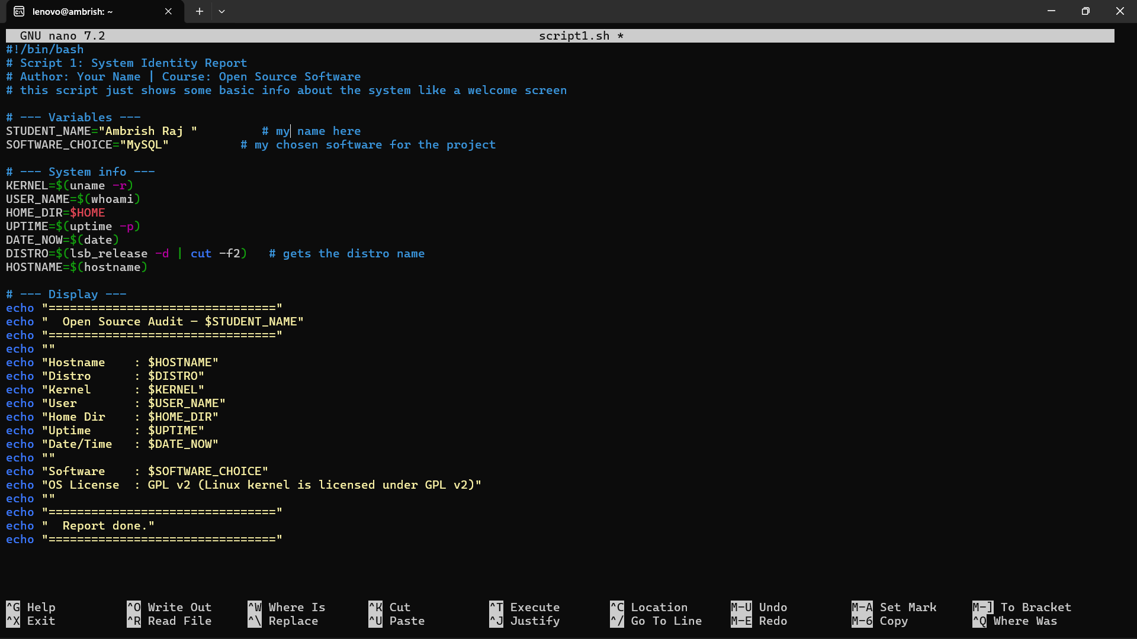

SCRIPT CODE:

#!/bin/bash
# Script 1: System Identity Report
# Author: [Your Name] | Course: Open Source Software
# this script just shows some basic info about the system like a welcome screen

# --- Variables ---
STUDENT_NAME="Ambrish Raj " # my name here
SOFTWARE_CHOICE="MySQL" # my chosen software for the project

# --- System info ---
KERNEL=$(uname -r)
USER_NAME=$(whoami)
HOME_DIR=$HOME
UPTIME=$(uptime -p)
DATE_NOW=$(date)
DISTRO=$(lsb_release -d | cut -f2) # gets the distro name
HOSTNAME=$(hostname)

# --- Display ---
echo "================================"
echo " Open Source Audit — $STUDENT_NAME"
echo "================================"
echo ""
echo "Hostname : $HOSTNAME"
echo "Distro : $DISTRO"
echo "Kernel : $KERNEL"
echo "User : $USER_NAME"
echo "Home Dir : $HOME_DIR"
echo "Uptime : $UPTIME"
echo "Date/Time : $DATE_NOW"
echo ""
echo "Software : $SOFTWARE_CHOICE"
echo "OS License : GPL v2 (Linux kernel is licensed under GPL v2)"
echo ""
echo "================================"
echo " Report done."
echo "================================"

SCRIPT OUTPUT :

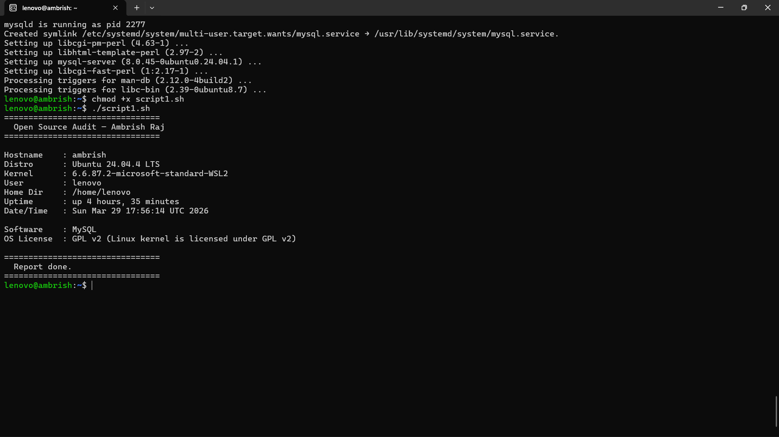

Script 2 — FOSS Package Inspector

What it does: The script checks for the installation of the mysql-server package and its version before displaying a brief summary depending on the package name.

Concepts Used: if-then-else, case statement, dpkg -l, pipe with grep, awk to access fields.

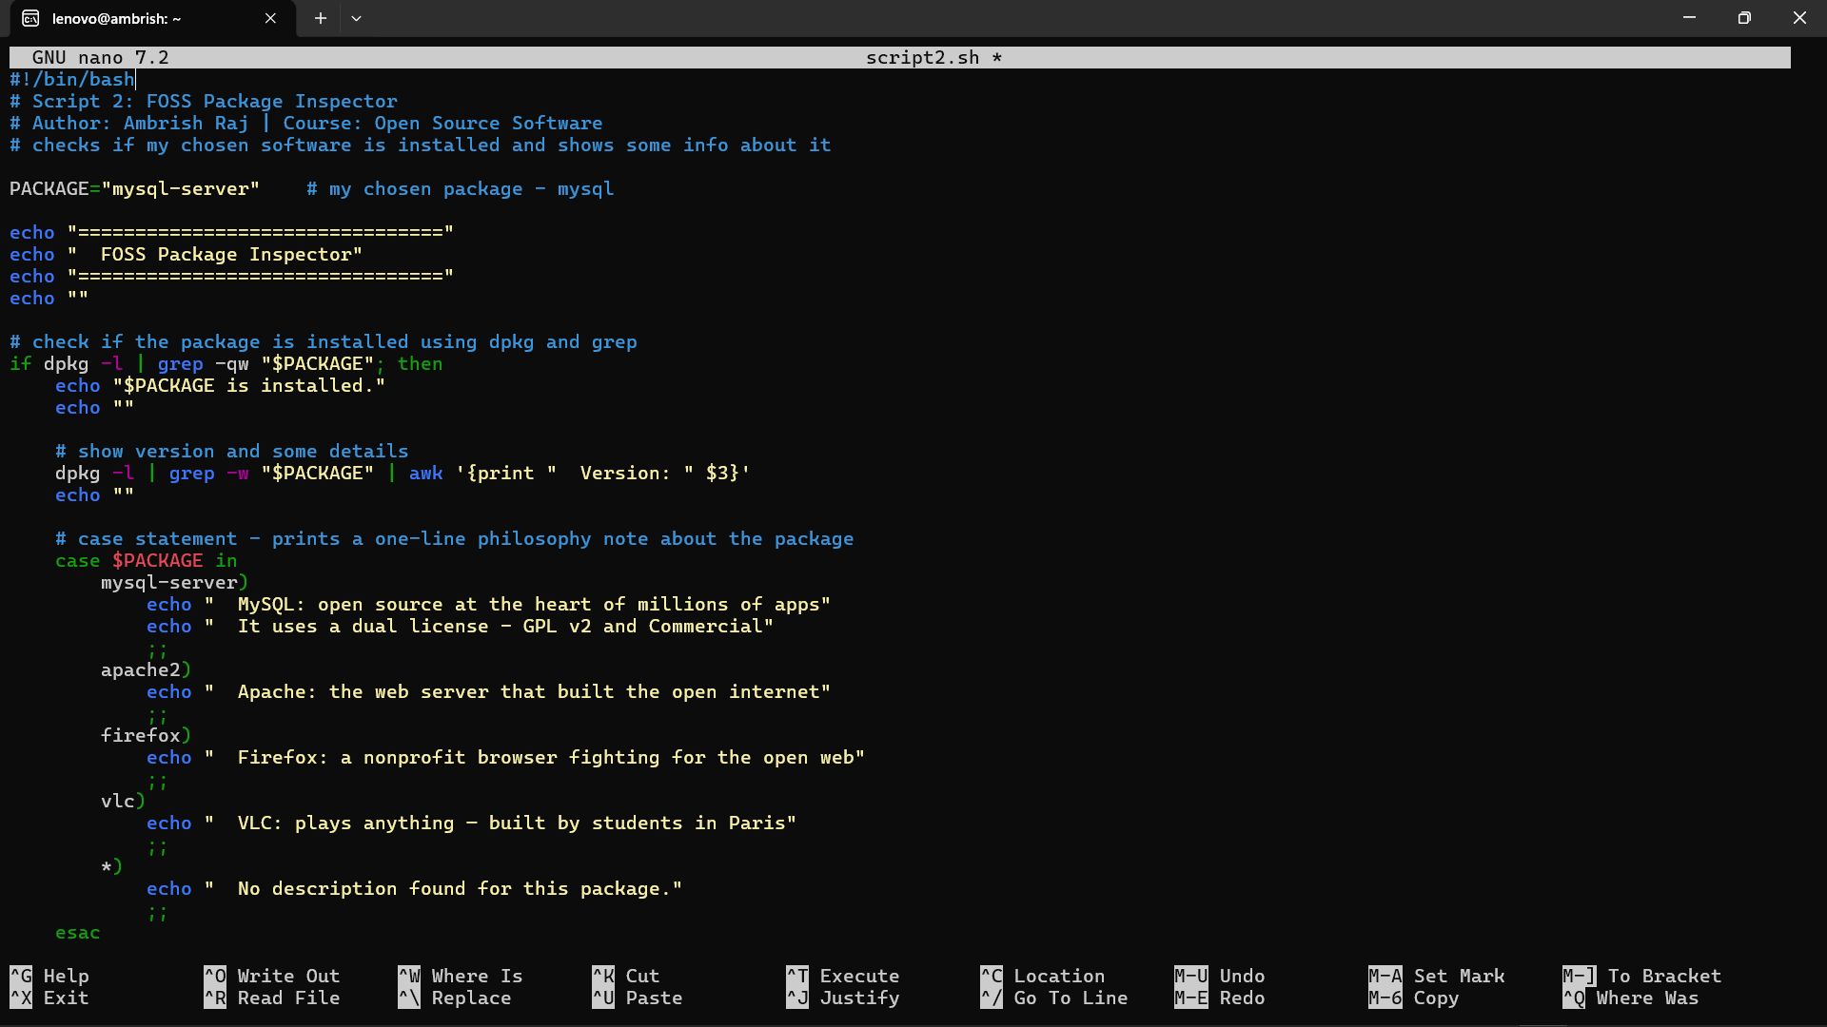
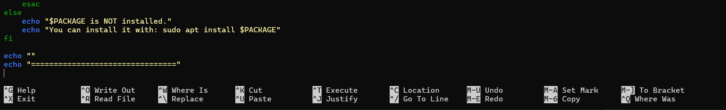

SCRIPT CODE:

#!/bin/bash
# Script 2: FOSS Package Inspector
# Author: Ambrish Raj | Course: Open Source Software
# checks if my chosen software is installed and shows some info about it

PACKAGE="mysql-server" # my chosen package - mysql

echo "================================"
echo " FOSS Package Inspector"
echo "================================"
echo ""

# check if the package is installed using dpkg and grep
if dpkg -l | grep -qw "$PACKAGE"; then
echo "$PACKAGE is installed."
echo ""

# show version and some details
dpkg -l | grep -w "$PACKAGE" | awk '{print " Version: " $3}'
echo ""

# case statement - prints a one-line philosophy note about the package
case $PACKAGE in
mysql-server)
echo " MySQL: open source at the heart of millions of apps"
echo " It uses a dual license - GPL v2 and Commercial"
;;
apache2)
echo " Apache: the web server that built the open internet"
;;
firefox)
echo " Firefox: a nonprofit browser fighting for the open web"
;;
vlc)
echo " VLC: plays anything — built by students in Paris"
;;
*)
echo " No description found for this package."
;;
esac
else
echo "$PACKAGE is NOT installed."
echo "You can install it with: sudo apt install $PACKAGE"
fi

echo ""
echo "================================"

SCRIPT OUTPUT :

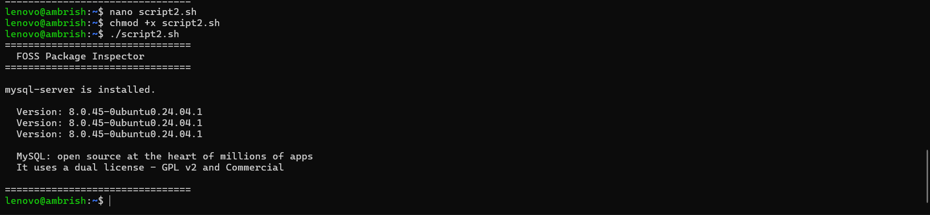

Script 3 - Disk and Permission Auditor

What it does: Loops through a list of important system directories (including MySQL's config and data directories), reports disk usage, owner, and permissions for each.

Concepts used: for loop, arrays, if conditional (-d check), du -sh, ls -ld, awk and cut for field extraction, printf for formatted output.

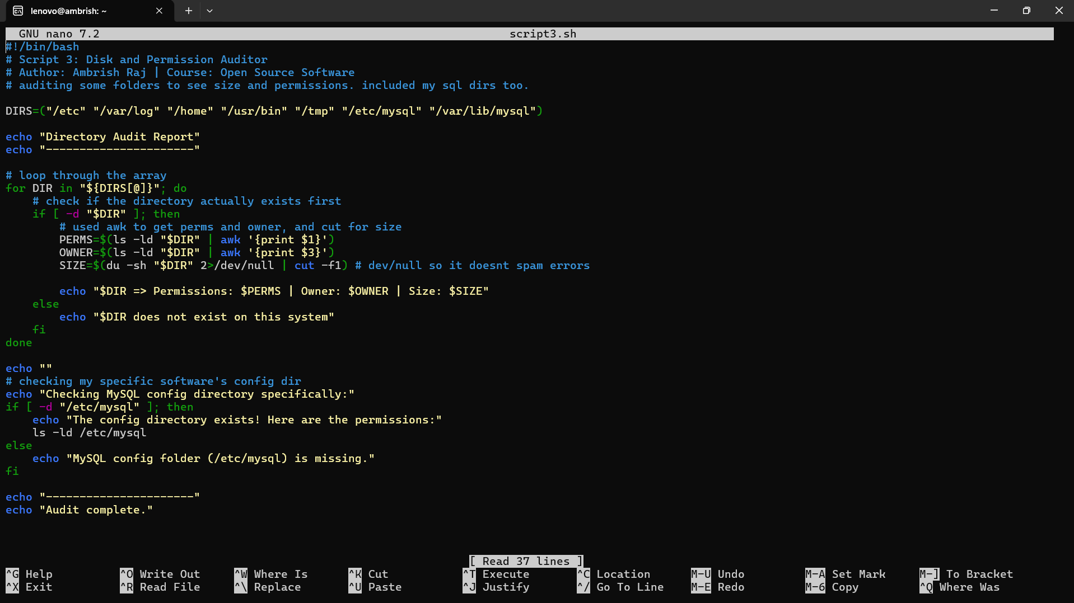

SCRIPT CODE :

#!/bin/bash
# Script 3: Disk and Permission Auditor
# Author: Ambrish Raj | Course: Open Source Software
# auditing some folders to see size and permissions. included my sql dirs too.

DIRS=("/etc" "/var/log" "/home" "/usr/bin" "/tmp" "/etc/mysql" "/var/lib/mysql")

echo "Directory Audit Report"
echo "----------------------"

# loop through the array
for DIR in "${DIRS[@]}"; do
# check if the directory actually exists first
if [ -d "$DIR" ]; then
# used awk to get perms and owner, and cut for size
PERMS=$(ls -ld "$DIR" | awk '{print $1}')
OWNER=$(ls -ld "$DIR" | awk '{print $3}')
SIZE=$(du -sh "$DIR" 2>/dev/null | cut -f1) # dev/null so it doesnt spam permission denied errors

echo "$DIR => Permissions: $PERMS | Owner: $OWNER | Size: $SIZE"
else
echo "$DIR does not exist on this system"
fi
done

echo ""
# checking my specific software's config dir
echo "Checking MySQL config directory specifically:"
if [ -d "/etc/mysql" ]; then
echo "The config directory exists! Here are the permissions:"
ls -ld /etc/mysql
else
echo "MySQL config folder (/etc/mysql) is missing."
fi

echo "----------------------"
echo "Audit complete."

SCRIPT OUTPUT :

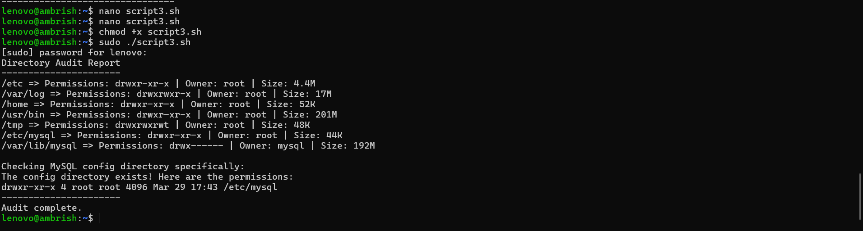

Script 4 – Log File Analyzer

The program reads each line from a log file to determine how many lines contain the keyword "error" by default and it displays the final five lines which matched the keyword. Uses command-line arguments for the log file path.
The following concepts appear in this example: while read loop, if-then structure, counter variables, command-line arguments ($1, $2), grep -iq, default values with ${2:-"error"}, tail + grep.

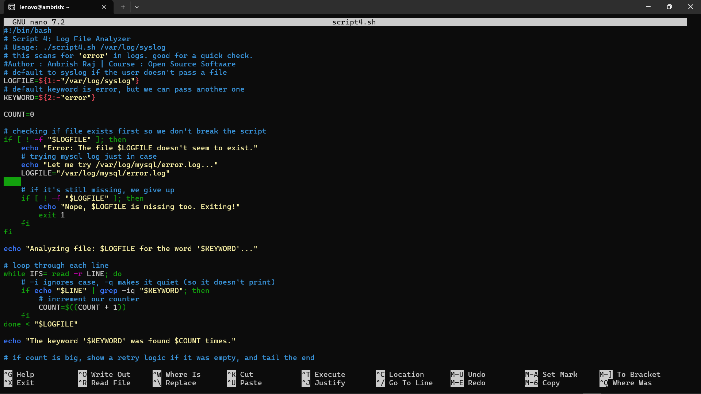

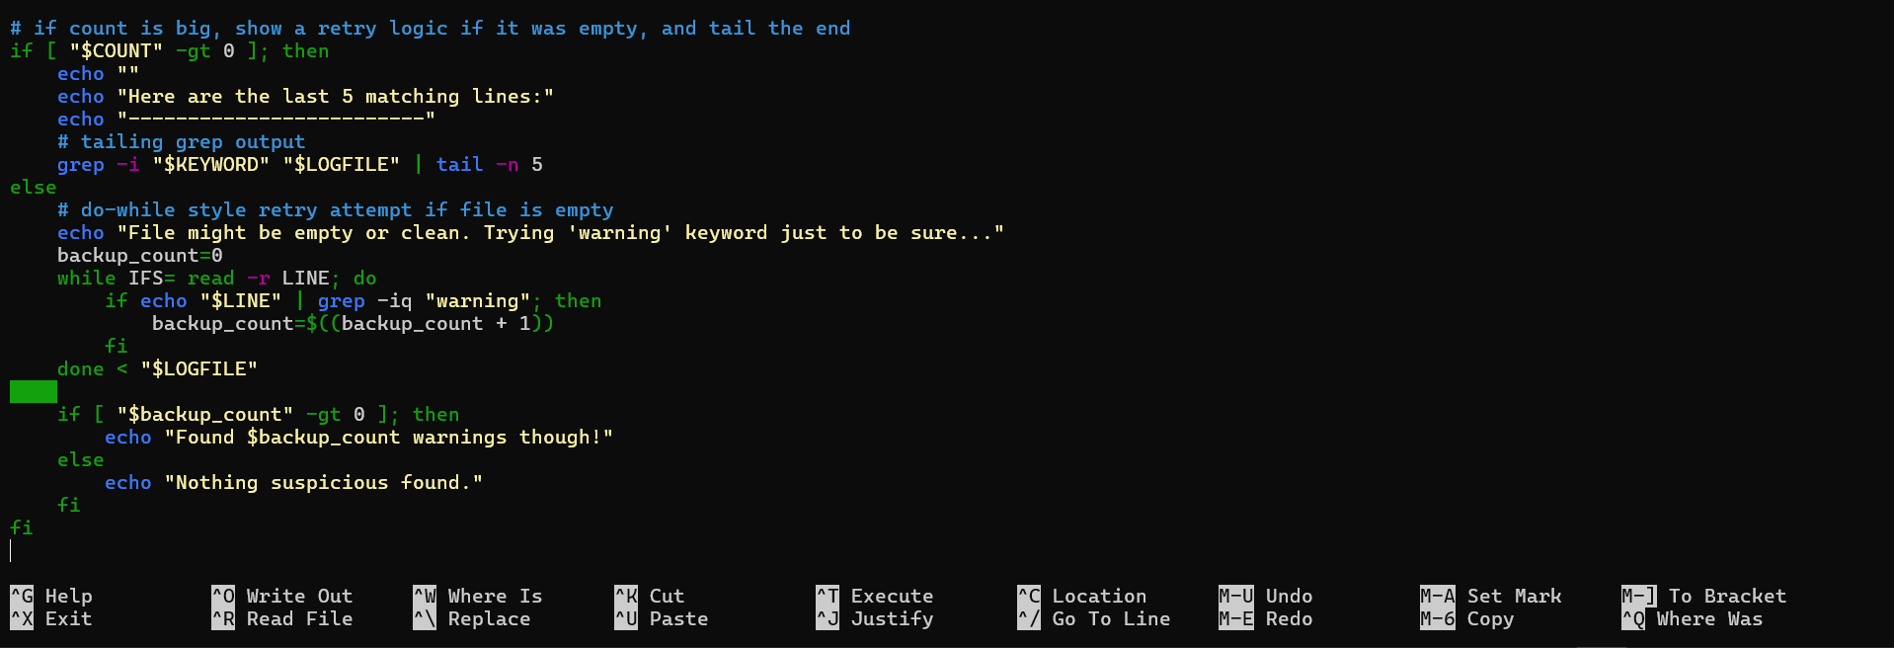

SCRIPT CODE:
#!/bin/bash
# Script 4: Log File Analyzer
# Usage: ./script4.sh /var/log/syslog
# this scans for 'error' in logs. good for a quick check.
# Author: Ambrish Raj | Course: Open Source Software
# default to syslog if the user doesn't pass a file
LOGFILE=${1:-"/var/log/syslog"}
# default keyword is error, but we can pass another one
KEYWORD=${2:-"error"}

COUNT=0

# checking if file exists first so we don't break the script
if [ ! -f "$LOGFILE" ]; then
echo "Error: The file $LOGFILE doesn't seem to exist."
# trying mysql log just in case
echo "Let me try /var/log/mysql/error.log..."
LOGFILE="/var/log/mysql/error.log"

# if it's still missing, we give up
if [ ! -f "$LOGFILE" ]; then
echo "Nope, $LOGFILE is missing too. Exiting!"
exit 1
fi
fi

echo "Analyzing file: $LOGFILE for the word '$KEYWORD'..."

# loop through each line
while IFS= read -r LINE; do
# -i ignores case, -q makes it quiet (so it doesn't print)
if echo "$LINE" | grep -iq "$KEYWORD"; then
# increment our counter
COUNT=$((COUNT + 1))
fi
done < "$LOGFILE"

echo "The keyword '$KEYWORD' was found $COUNT times."

# if count is big, show a retry logic if it was empty, and tail the end
if [ "$COUNT" -gt 0 ]; then
echo ""
echo "Here are the last 5 matching lines:"
echo "-------------------------"
# tailing grep output
grep -i "$KEYWORD" "$LOGFILE" | tail -n 5
else
# do-while style retry attempt if file is empty
echo "File might be empty or clean. Trying 'warning' keyword just to be sure..."
backup_count=0
while IFS= read -r LINE; do
if echo "$LINE" | grep -iq "warning"; then
backup_count=$((backup_count + 1))
fi
done < "$LOGFILE"

if [ "$backup_count" -gt 0 ]; then
echo "Found $backup_count warnings though!"
else
echo "Nothing suspicious found."
fi
fi

SCRIPT OUTPUT :

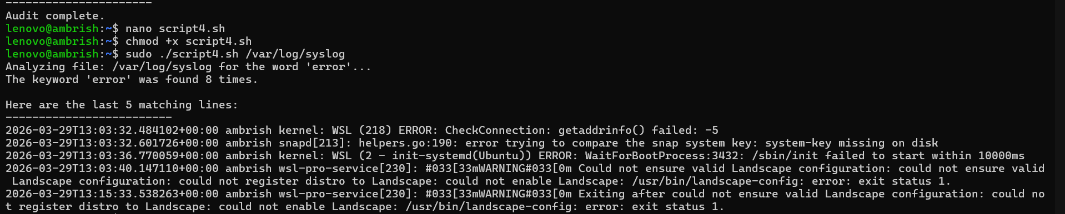

Script 5 – Open Source Manifesto Generator

The program asks users three questions through an interactive process which generates an individual open-source philosophy statement based on their responses. The program creates a .txt file to store the generated statement which it then shows to the user.

The program reads user input through the read command while it uses string concatenation to create output. The program writes data to files through the > and >> operators. The date command executes in the system. The cat command shows file content to users. The program shows alias usage through its comment section.
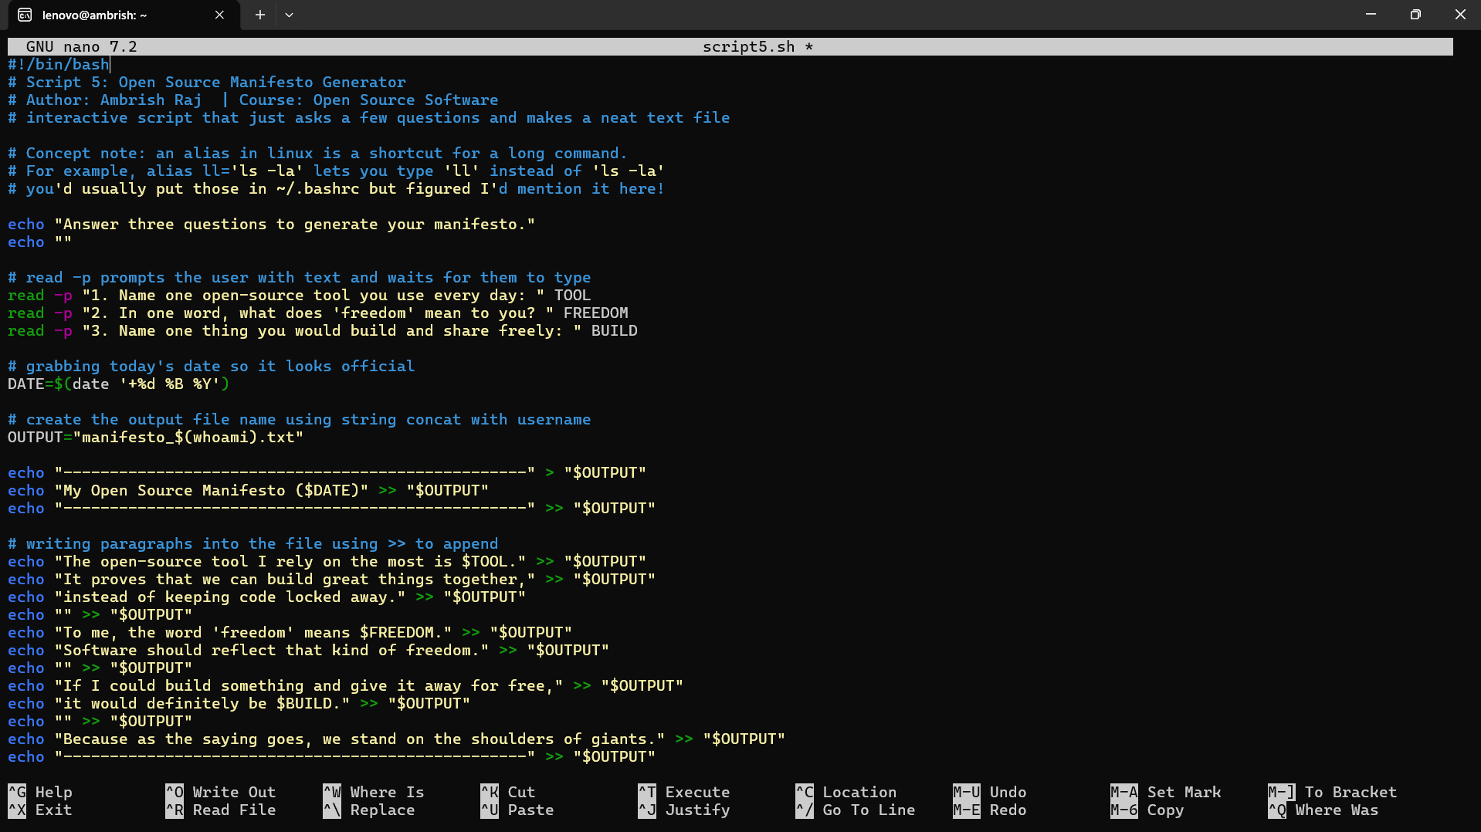

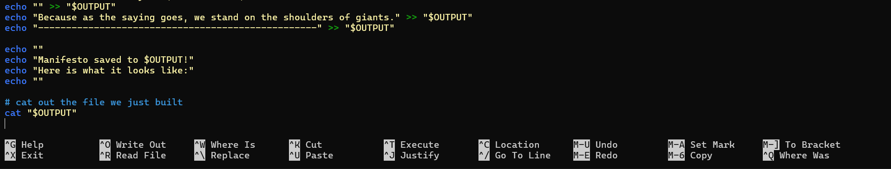

SCRIPT CODE:

#!/bin/bash
# Script 5: Open Source Manifesto Generator
# Author: Ambrish Raj | Course: Open Source Software
# interactive script that just asks a few questions and makes a neat text file

# Concept note: an alias in linux is a shortcut for a long command.
# For example, alias ll='ls -la' lets you type 'll' instead of 'ls -la'
# you'd usually put those in ~/.bashrc but figured I'd mention it here!

echo "Answer three questions to generate your manifesto."
echo ""

# read -p prompts the user with text and waits for them to type
read -p "1. Name one open-source tool you use every day: " TOOL
read -p "2. In one word, what does 'freedom' mean to you? " FREEDOM
read -p "3. Name one thing you would build and share freely: " BUILD

# grabbing today's date so it looks official
DATE=$(date '+%d %B %Y')

# create the output file name using string concat with username
OUTPUT="manifesto_$(whoami).txt"

echo "--------------------------------------------------" > "$OUTPUT"
echo "My Open Source Manifesto ($DATE)" >> "$OUTPUT"
echo "--------------------------------------------------" >> "$OUTPUT"

# writing paragraphs into the file using >> to append
echo "The open-source tool I rely on the most is $TOOL." >> "$OUTPUT"
echo "It proves that we can build great things together," >> "$OUTPUT"
echo "instead of keeping code locked away." >> "$OUTPUT"
echo "" >> "$OUTPUT"
echo "To me, the word 'freedom' means $FREEDOM." >> "$OUTPUT"
echo "Software should reflect that kind of freedom." >> "$OUTPUT"
echo "" >> "$OUTPUT"
echo "If I could build something and give it away for free," >> "$OUTPUT"
echo "it would definitely be $BUILD." >> "$OUTPUT"
echo "" >> "$OUTPUT"
echo "Because as the saying goes, we stand on the shoulders of giants." >> "$OUTPUT"
echo "--------------------------------------------------" >> "$OUTPUT"

echo ""
echo "Manifesto saved to $OUTPUT!"
echo "Here is what it looks like:"
echo ""

# cat out the file we just built
cat "$OUTPUT"

SCRIPT OUTPUT :

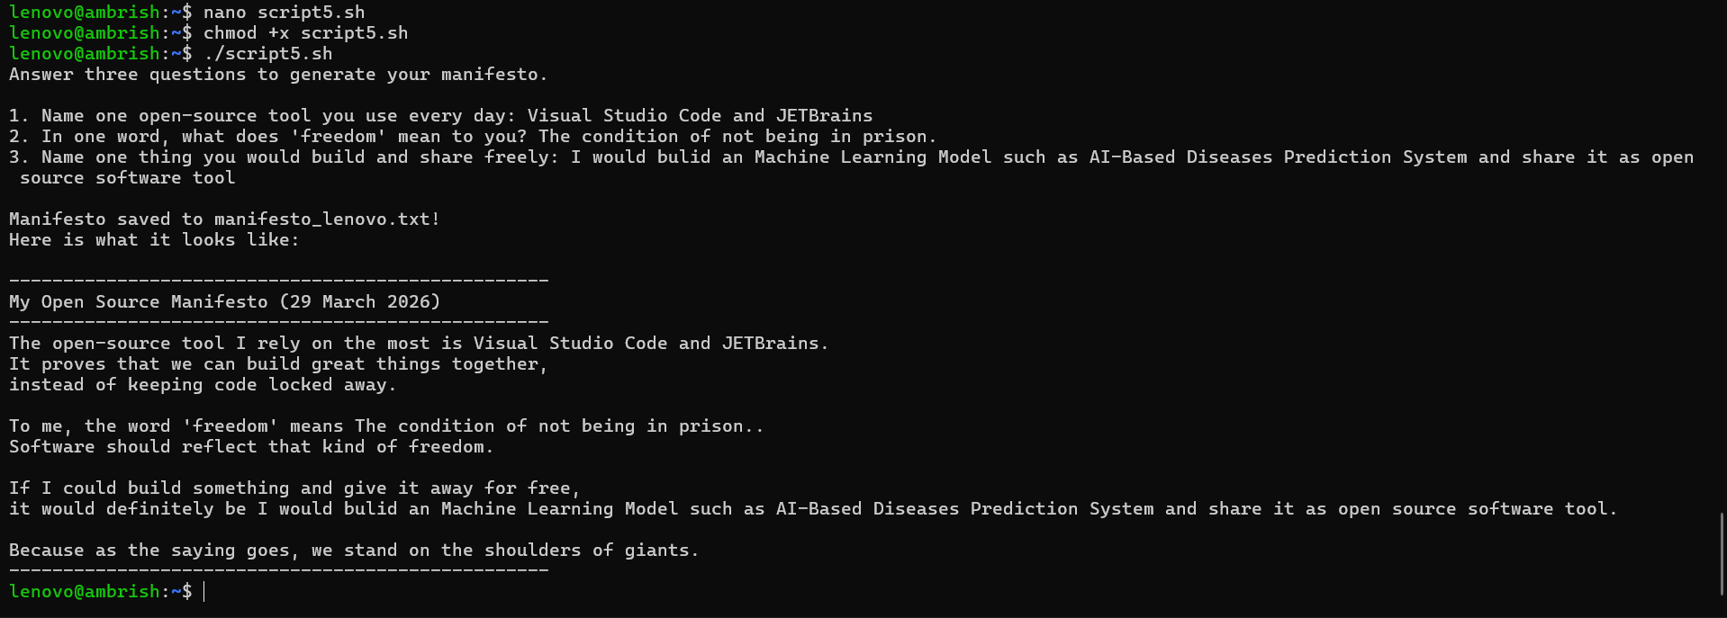

References

Use these as starting points, not as sources to copy from. The report has been written in my own understanding and words.

On open source philosophy

GNU Project — The Free Software Definition:

https://www.gnu.org/philosophy/free-sw.html

Open Source Initiative — The Open Source Definition

https://opensource.org/osd

Eric S. Raymond — The Cathedral and the Bazaar: http://catb.org/~esr/writings/cathedral-bazaar

On MySQL

- MySQL Official Documentation:
https://dev.mysql.com/doc/
- MySQL GitHub Repository:
https://github.com/mysql/mysql-server
- MySQL License (GPL v2):
https://www.gnu.org/licenses/old-licenses/gpl-2.0.html

On Linux and shell scripting
- The Linux Command Line by William Shotts: https://linuxcommand.org/
- GNU Bash Manual:
https://www.gnu.org/software/bash/manual/
- Linux man pages: https://manpages.ubuntu.com/

For finding license texts
- SPDX License List:
https://spdx.org/licenses/

- Choose a License:
https://choosealicense.com/
- MySQL official repository (LICENSE file): https://github.com/mysql/mysql-server

A closing thought
Every single tool that I will be using in my profession—every framework, every library, every compiler—is built on top of an open-source base. The philosophy behind that is not optional; it is mandatory in order to be a professional in this field. I learned about MySQL operations through this project while also discovering its original purpose and the team who created it and the licensing rules which users can follow.

